Order Of Lenten Service

Opening Hymn: TLH 160

Reading: Lent VII

The History of the Passion of our Lord

Palm Sunday Reading: John 12:12-18

Sermon Hymn: TLH 161

Sermon Text: Luke 12:54-56

Discerning The Times

Confession of Sins: O almighty God, merciful Father, I, a poor miserable sinner, confess unto Thee all my sins and iniquities, with which I have ever offended Thee and justly deserved Thy temporal and eternal punishment. But I am heartily sorry for them and sincerely repent of them, and I pray Thee of Thy boundless mercy and for the sake of the holy, innocent, bitter sufferings and death of Thy beloved Son, Jesus Christ, to be gracious and merciful to me, a poor, sinful being.

Holy Communion

The Lord's Prayer

The Blessing

Closing Hymn: TLH 162

* * * * * * * * * * * * *
Bible Study: Lambs: Palm Tree
Sheep: Philippians

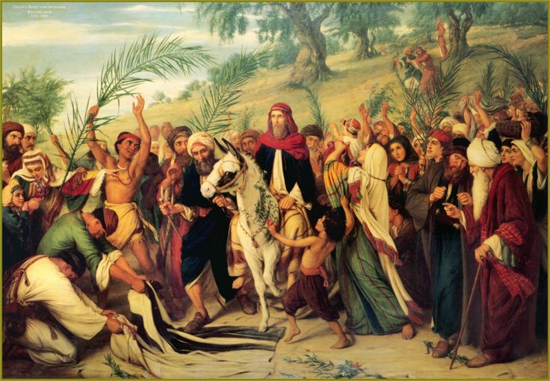

Palm Sunday

Water
Of
Life

10 April 2022

W A T E R O F L I F E

Independent Christian Church—Conservative Lutheran Doctrine

Worship Service: 9:30 a.m. Bible Study: 10:45 a.m.

Larry Cooper, Pastor E-Mail address:
111 N. Ridge Road lcooper@wateroflife.cc
Coon Valley, WI 54623 Web Site:
www.wateroflife.cc

* * * * * * * * * * * * * * * * * * * * * * * * * * *

Sermon Text: Luke 12:54-56

Discerning The Times

* * * * * * * * * * * * * * * * * * * * * * * * * * *

54 And he said also to the people, When ye see a cloud rise out of the west, straightway ye say, There cometh a shower; and so it is.
55 And when ye see the south wind blow, ye say, There will be heat; and it cometh to pass.
56 Ye hypocrites, ye can discern the face of the sky and of the earth; but how is it that ye do not discern this time?



